clc;clear;close all
load GWO_3000t
load woa_3000t
load system_3000t
% load('system.mat')
figure()
plot(speed_GWO)
hold on
plot(speed_woa,'r')
title('speed')
plot(speed,'k')
plot([0 5],[3000 3000],'b--')
title('Speed')
xlabel('Time [S]')
legend('GWO','WOA',...
'intial System',...
'refrence',...
'location','southeast','fontsize',15)
xlim([0 1])
T1=voltage_GWO.time;S1=speed_GWO.data;
T2=speed_woa.time;S2=speed_woa.data;
T3=speed.time;S3=speed.data;
disp('************')
disp('GWO Step Info')
stepinfo(S1,T1)
disp('************')
disp('WOA Step Info')
stepinfo(S2,T2)
disp('************')
disp('Intial Syste, Step Info')
stepinfo(S3,T3)
disp('************')
figure()
t1=voltage_GWO.time;d1=voltage_GWO.data;
t2=voltage_woa.time;d2=voltage_woa.data;
t3=voltage.time;d3=voltage.data;
subplot(311)
plot(t1(5:end),d1(5:end));title('Voltage GWO')
subplot(312)
plot(t2(5:end),d2(5:end),'r');title('Voltage WOA')
subplot(313)
plot(t3(5:end),d3(5:end),'k');title('Voltage')
figure()
t1=current_GWO.time;d1=current_GWO.data;
t2=current_woa.time;d2=current_woa.data;
t3=current.time;d3=current.data;
subplot(311)
plot(t1,d1);title('Current GWO')
subplot(312)
plot(t2,d2,'r');title('Current WOA')
subplot(313)
plot(t3,d3,'k');title('Current')
figure()
t1=control_GWO.time;d1=control_GWO.data;
t2=control_woa.time;d2=control_woa.data;
t3=control.time;d3=control.data;
subplot(311)
plot(t1(15:end),d1(15:end));title('Control GWO')
subplot(312)
plot(t2(15:end),d2(15:end),'r');title('Control WOA')
subplot(313)
plot(t3(15:end),d3(15:end),'k');title('Control')
figure()
t1=torque_GWO.time;d1=torque_GWO.data;
t2=torque_woa.time;d2=torque_woa.data;
t3=torque.time;d3=torque.data;
subplot(311)
plot(t1,d1);title('Torque GWO')
subplot(312)
plot(t2,d2,'r');title('Torque WOA')
subplot(313)
plot(t3,d3,'k');title('Torque')
disp('GWO PID')
fprintf('P = %1.4f \n I = %1.4f \n D = %1.4f \n',P_GWO,I_GWO,D_GWO)
disp('WOA PID')
fprintf('P = %1.4f \n I = %1.4f \n D = %1.4f \n',P_woa,I_woa,D_woa)
disp('PID')
fprintf('P = %1.4f \n I = %1.4f \n D = %1.4f \n',P,I,D)
************
GWO Step Info
ans =
struct with fields:
RiseTime: 0.0378
SettlingTime: 0.8291
SettlingMin: 2.4950e+03
SettlingMax: 2.9774e+03
Overshoot: 0.1453
Undershoot: 0
Peak: 2.9774e+03
PeakTime: 0.9312
************
WOA Step Info
ans =
struct with fields:
RiseTime: 0.0448
SettlingTime: 0.8072
SettlingMin: 2.4949e+03
SettlingMax: 3.0096e+03
Overshoot: 0.1090
Undershoot: 0
Peak: 3.0096e+03
PeakTime: 0.8971
************
Intial Syste, Step Info
ans =
struct with fields:
RiseTime: 0.0525
SettlingTime: 0.8376
SettlingMin: 2.4938e+03
SettlingMax: 2.9839e+03
Overshoot: 0.1494
Undershoot: 0
Peak: 2.9839e+03
PeakTime: 0.9878
************
GWO PID
P = 9.9070
I = 3.5511
D = 0.1707
WOA PID
P = 0.0020
I = 0.5000
D = 0.0000
PID
P = 4.6689
I = 2.5465
D = 0.1113
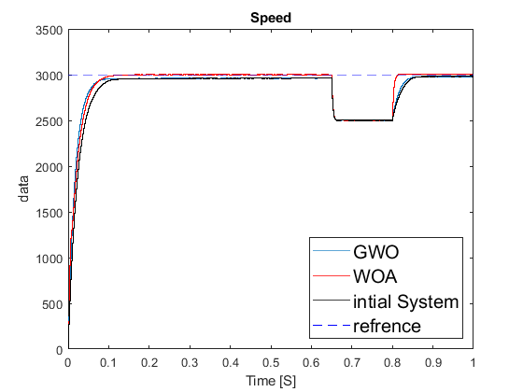
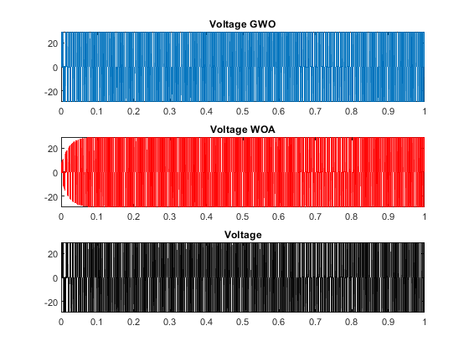
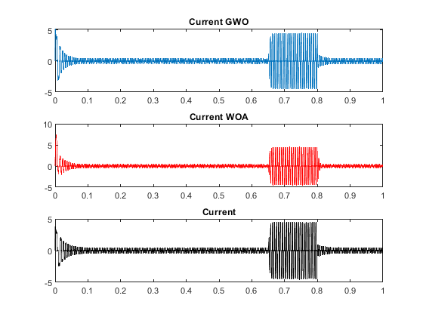
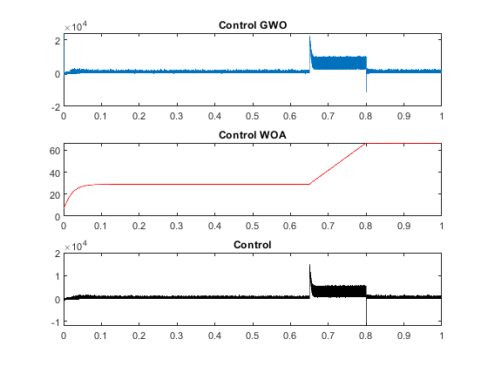
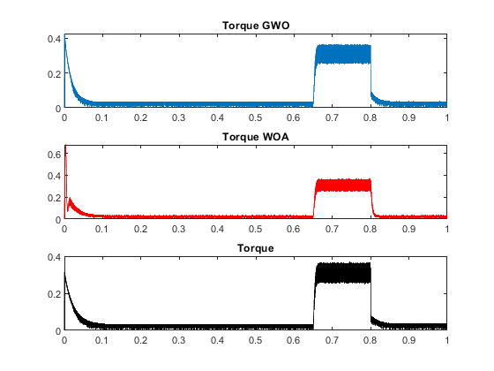
Published with MATLAB® R2020b

